**DISK MANAGEMENT**

**WHAT IS FILE SYSTEM?**

* File System is a method to store and organize files and directories on disk.
* A file system can have different formats called file system types.
* These formats determine how the information is stored as files and directories.

**WINDOWS FILE SYSTEM:**

* FAT
* FAT32
* NTFS

**LINUX FILE SYSTEM:**

* ext1
* ext2
* ext3
* ext4 - Default file system in RHEL/OEL- 6
* XFS - Default filesystem in RHEL/OEL - 7/8/9

**XFS FILE SYSTEM:**

* The XFS file system is an extension of the extent file system.
* The XFS is a high-performance 64-bit journaling file system.
* The support of the XFS was merged into Linux kernel in around 2002 and In 2009 Red Hat Enterprise Linux version 5.4 usage of the XFS file system.
* XFS supports maximum file system size of 8 exbibytes for the 64-bit file system.
* There is some comparison of XFS file system is XFS file system can’t be shrunk and poor performance with deletions of the large numbers of files.
* Now, the RHEL 7.0 uses XFS as the default filesystem.

**Create filesystem using raw disk:**

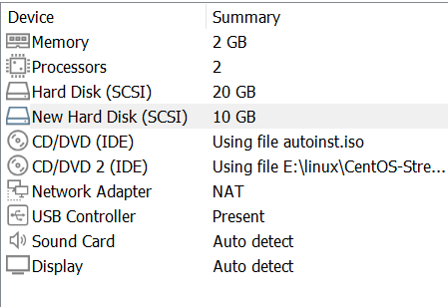

**scan disk**

# echo '- - -' > /sys/class/scsi_host/host0/scan



**LSBLK Command:**

* lsblk command is used to list information about all available block devices in Linux

**SYNTAX:**

* lsblk

**HOW TO CREATE A NEW DISK LINUX?**

1. **To check a Default disk by using lsblk Command:**

* lsblk

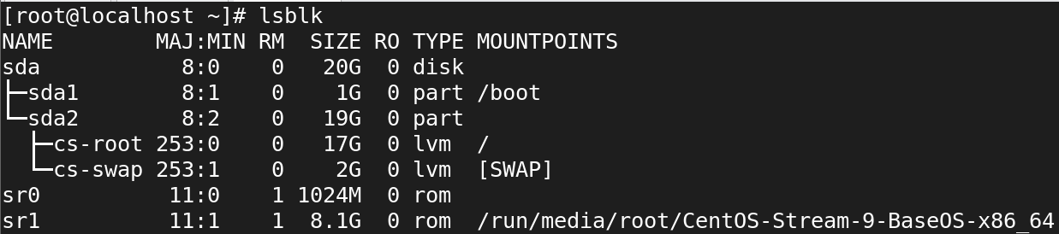

1. **Now check the created Disk shown after scan:**

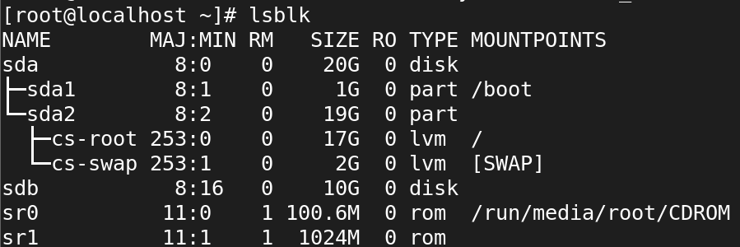

1. **Make file system for the newly created disk:**

* mkfs.xfs /dev/sdb

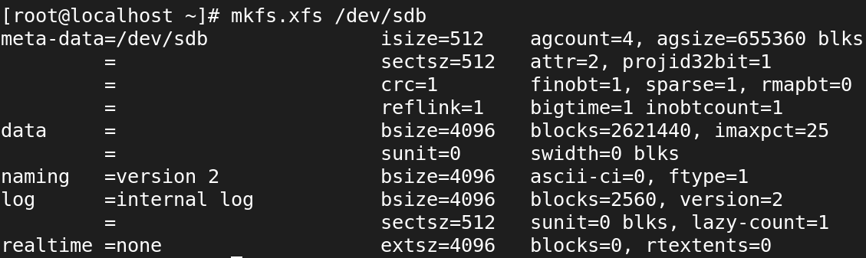

1. **Create mount point - /<dir name>:**

* mount /dev/sdb /<dir name>



1. **To check mounted or not**:

* df -h

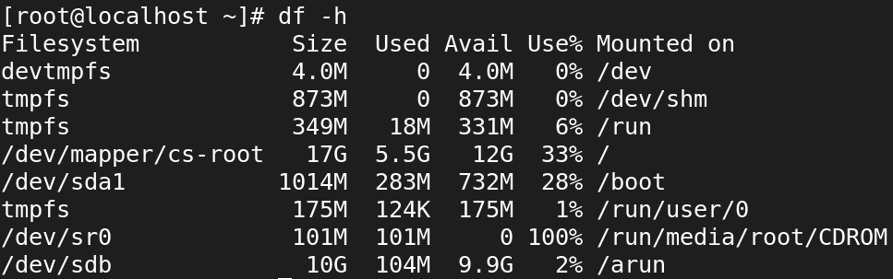

1. **After create files in mounted directory:**



* The created files don’t show after reboot.
* The mounted directed also disable.

1. **For Permanent mount by using fstab:**

* vi /etc/fstab



1. **After rebooting, mounted directories:**

* df -Th

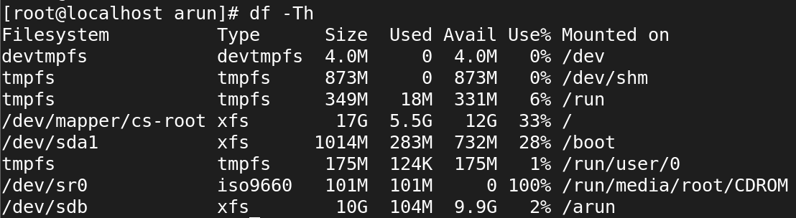

**Partition Table:**

* Partition can be considered as a piece of disk space.A partition table is a partition of a disk that contains

**The two most popular partition tables:**

* Master Boot Record (MBR) partition
* GUID Partition Table (GPT) partition

**MBR (dos) partition:**

We can create max 4 partition

* 3 primary
* 1 Extended

**GPT partition:**

we can create 128 partitions

**To create file system with partition**

**Create new disk:**

selete VM ---> setting ---> attach disk

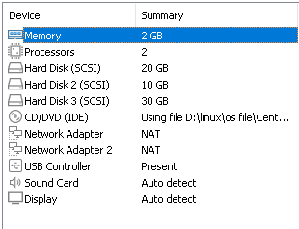

**scan disk**

* echo '- - -' > /sys/class/scsi_host/host0/scan



**To check disk is shown:**

* lsblk

sdb – new disk



1. **Commands to create partition:**

* fdisk <disk name>

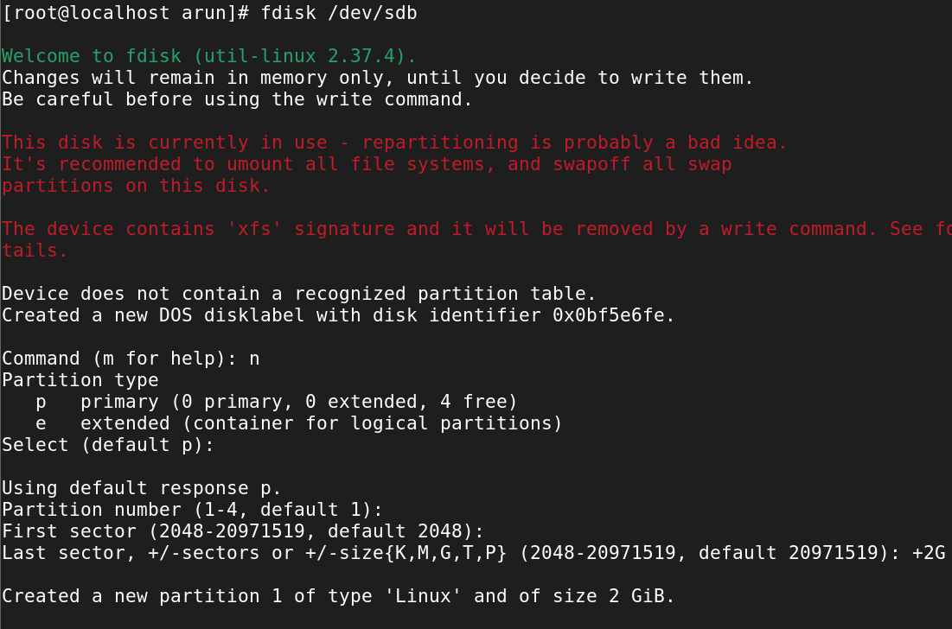

1. **To check partition is created or not:**

* lsblk

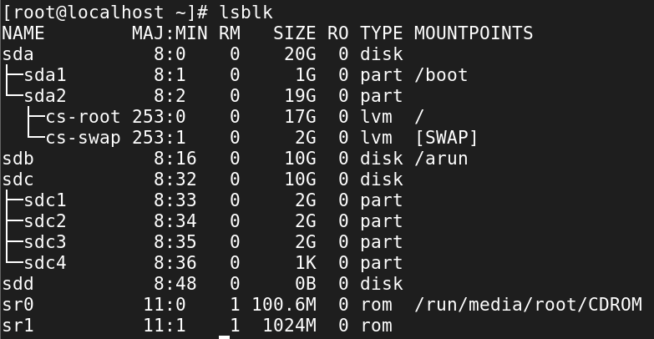

1. **To make file system with 1 partition:**

* mkfs.xfs /dev/sdc

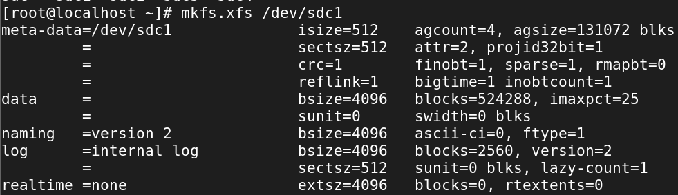

1. **Mount the directory:**

* mount /dev/sdc1 /devaki



1. **Check whether is mounted or not:**

* df -Th

